

Semester Two Examination, 2019

Question/Answer booklet

MATHEMATICS

SOLUTIONS
APPLICATIONS
UNITS 3 AND 4

Section Two:

Calculator-assumed

Student number: In figures

In words

Your name

Time allowed for this section
Reading time before commencing work: ten minutes
Working time: one hundred minutes

Materials required/recommended for this section
To be provided by the supervisor
This Question/Answer booklet
Formula sheet (retained from Section One)

To be provided by the candidate
Standard items: pens (blue/black preferred), pencils (including coloured), sharpener,
correction fluid/tape, eraser, ruler, highlighters

Special items: drawing instruments, templates, notes on two unfolded sheets of A4 paper, and up to three calculators approved for use in this examination

Important note to candidates
No other items may be taken into the examination room. It is your responsibility to ensure that you do not have any unauthorised material. If you have any unauthorised material with you, hand it to the supervisor before reading any further.

Structure of this paper

Section | Number of questions available | Number of questions to be answered | Working  time (minutes) | Marks available | Percentage of examination
Section One:  Calculator-free | 8 | 8 | 50 | 52 | 35
Section Two:  Calculator-assumed | 13 | 13 | 100 | 98 | 65
 |  |  |  | Total | 100

Instructions to candidates

1. The rules for the conduct of examinations are detailed in the school handbook. Sitting this examination implies that you agree to abide by these rules.

2. Write your answers in this Question/Answer booklet preferably using a blue/black pen.
Do not use erasable or gel pens.

3. You must be careful to confine your answer to the specific question asked and to follow any instructions that are specified to a particular question.

4. Show all your working clearly. Your working should be in sufficient detail to allow your answers to be checked readily and for marks to be awarded for reasoning. Incorrect answers given without supporting reasoning cannot be allocated any marks. For any question or part question worth more than two marks, valid working or justification is required to receive full marks. If you repeat any question, ensure that you cancel the answer you do not wish to have marked.

5. It is recommended that you do not use pencil, except in diagrams.

6. Supplementary pages for planning/continuing your answers to questions are provided at the end of this Question/Answer booklet. If you use these pages to continue an answer, indicate at the original answer where the answer is continued, i.e. give the page number.

7. The Formula sheet is not to be handed in with your Question/Answer booklet.

Section Two: Calculator-assumed 65% (98 Marks)
This section has thirteen (13) questions. Answer all questions. Write your answers in the spaces provided.

Working time: 100 minutes.

Question 9 (6 marks)
(a) Connected planar graph $G_{1}$ has $18$ faces and $25$ edges. Determine the number of vertices $G_{1}$ has. (2 marks)
Solution
$$18+v-25=2 \\ v=9$$

Specific behaviours
indicates use of Euler's formula
✓ correct number

(b) Draw graph $G_{2}$ so that it has $6$ vertices, is a tree and is not semi-Eulerian. (2 marks)
Solution
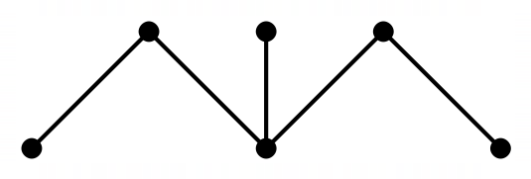
(example solution)
Specific behaviours
tree using 6 vertices
✓ not semi-Eulerian

(c) Graph $G_{3}$ is shown below. Redraw $G_{3}$ to clearly show that it is bipartite, underlining vertex $A$ and the other vertices that belong to its group. (2 marks)

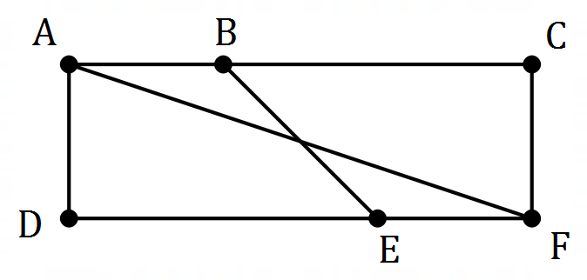
Solution
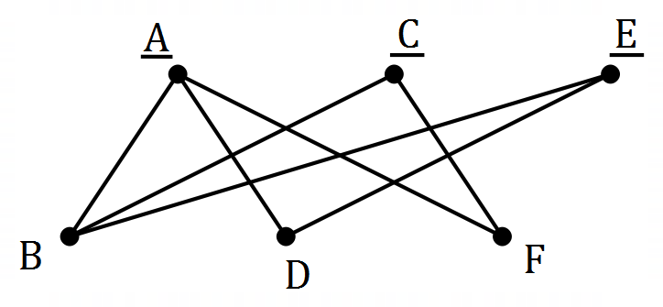
(example solution)
Specific behaviours
clearly bipartite
✓ underlines $A, C$ and $E$

Question 10 (6 marks)
The number of tickets $T_{n}$ remaining for a musical event at the start of day $n$ can be modelled by the recursive rule $T_{n+1}=T_{n}-17$. At the start of day $1$, there were $646$ tickets remaining.

(a) Complete the table below. (2 marks)

$$n$$ | $$5$$ | $$10$$ | $$15$$ | $$20$$
$$T_{n}$$ | $$578$$ | $$493$$ | $$408$$ | $$323$$

Solution
See table
Specific behaviours
at least two correct entries
✓ all correct entries

(b) Would the graph of $T_{n}$ against $n$ appear to be linear or non-linear? (1 mark)
Solution
Linear

Specific behaviours
correct type

(c) The $n$^{th} term rule for this sequence is $T_{n}=b+an$. Determine the value of the constant $a$ and the value of the constant $b$. (2 marks)
Solution
$$T_{n}=646+\left(n-1\right)\left(-17\right) \\ =646-17n+17 \\ =663-17n$$

Hence $a=-17$ and $b=663$.

Specific behaviours
value of $a$
✓ value of $b$

(d) At the start of day $k$, fewer than $50$ tickets remain. State the value of $k$. (1 mark)
Solution
$$k=37$$

Specific behaviours
correct value

Question 11 (11 marks)
The scatterplot and table below show the length ($L$) and the weight ($W$) of some mackerel, a species of fish.

$L$ (cm) | $$25$$ | $$32$$ | $$39$$ | $$30$$ | $$42$$ | $$28$$ | $$35$$ | $$44$$ | $$33$$ | $$36$$ | $$27$$ | $$38$$
$W$ (kg) | $$0.21$$ | $$0.39$$ | $$0.77$$ | $$0.41$$ | $$0.83$$ | $$0.38$$ | $$0.55$$ | $$0.85$$ | $$0.52$$ | $$0.62$$ | $$0.25$$ | $$0.58$$

(a) By viewing a scatterplot of this data on your calculator, identify and describe the direction and form of the relationship between the variables. (2 marks)
Solution
Direction is positive and form is linear.

Specific behaviours
states positive direction
✓ states linear form

(b) Calculate the correlation coefficient between the variables and use it to describe the strength of their association. (2 marks)
Solution
$r=0.975$.
Hence the strength of association is strong.
Specific behaviours
correct coefficient
✓ states strong association

(c) What percentage of the variation in weight can be explained by the variation in the length for this sample? (1 mark)
Solution
$$r^{2}=0.950⇒95\%$$
Specific behaviours
correct percentage

(d) Using length as the explanatory variable, determine the equation of the least-squares line to model the linear relationship between the variables. (2 marks)
Solution
$$W=0.0345L-0.647$$
Specific behaviours
correct coefficients
✓ uses correct variables

(e) What increase in weight can be expected for each additional centimetre in length for these mackerel? (1 mark)
Solution
$0.0345$ kg or $34.5$ grams
Specific behaviours
weight with units

(f) Another mackerel in the sample had a length of $41$ cm. Predict the weight of this fish and comment on two factors that support the reliability of this prediction. (3 marks)
Solution
$\hat{W}(41)=0.77$ kg. Reliable because a strong linear association exists, and prediction is interpolated.

Specific behaviours
correct prediction
✓ notes interpolation
✓ notes strong association

Question 12 (6 marks)
An investor is considering placing the sum of $\$75 000$ into one of three investments for $2$ years.

Investment A offers a return of $7.65\%$ compounded quarterly.

(a) Determine the profit that the investor would achieve through investment A. (2 marks)
Solution
$$FV=\$87 273.20$$

$$\text{Profit}=\$12 273.20$$

Specific behaviours
future value
✓ profit

Investment B offers a return of $7.58\%$ compounded daily.

(b) Calculate the difference in profit that the investor would achieve through investment B compared to investment A. (2 marks)
Solution
$$FV=\$87 275.73$$

$$\text{Difference}=5.73-3.20=\$2.53$$

Specific behaviours
future value for B
✓ difference

Investment C offers a return of $7.6\%$ compounded monthly.

(c) Rank the three investments in order, from highest to lowest profit. Justify your answer.
(2 marks)
Solution
Effective interest rates are:

$$A:7.8723\%$$
$$B:7.8738\%$$
$$C:7.8704\%$$

Ranking: $B, A, C$

Specific behaviours
effective rates or other comparison
✓ correct ranking (must be justified)

Question 13 (6 marks)
A random sample of $450$ TAFE students studying the same diploma was taken. Their study mode and enjoyment of the course is summarised in the table below.

 |  | Study mode
 |  | Attend campus | Online
Level of course enjoyment | High | $$114$$ | $$45$$
 | Moderate | $$140$$ | $$52$$
 | Low | $$55$$ | $$23$$
 | None | $$16$$ | $$5$$

(a) Show that the study mode of approximately $72\%$ of the students in the sample is to attend campus. (2 marks)
Solution
$$114+140+55+16=325$$

$$325÷450=0.722≈72\%$$

Specific behaviours
column total
✓ shows percent calculation

(b) Complete the two-way frequency table below to show the column percentages for the above data, rounding to the nearest whole number. (2 marks)

 |  | Study mode
 |  | Attend campus | Online
Level of course enjoyment | High | $$35$$ | $$36$$
 | Moderate | $$43$$ | $$42$$
 | Low | $$17$$ | $$18$$
 | None | $$5$$ | $$4$$
Solution
See table (no penalty if not rounded)
Specific behaviours
all values in one column
✓ both columns correct

(c) Explain whether the data suggests the presence of an association between the variables.
(2 marks)
Solution
No evidence that level of course enjoyment for this diploma is associated with study mode because across all four rows, both values are very similar.

Specific behaviours
states no association
✓ explanation for no association

Question 14 (5 marks)
A young person has a bank account that pays no interest. At the start of each week they withdraw a fixed percentage of the balance to spend and then deposit a lump sum from their wages. The balance of the account at the end of week $n$ is given by $A_{n}$, where

$$A_{n+1}=0.92A_{n}+28, A_{1}=74.92.$$

(a) Calculate $A_{5}$ and explain what this figure represents.
(2 marks)
Solution
$$A_{5}=\$152.93$$

This is the amount in the account at the end of week $5$.
Specific behaviours
amount to nearest cent
✓ explanation

(b) State what percentage of the balance they withdraw each week. (1 mark)

Solution
$$1-0.92=0.08=8\%$$

Specific behaviours
correct percentage

(c) The young person plans to continue operating the account in this manner until it holds at least $\$500$. Comment on this plan. (2 marks)
Solution
Not possible for the balance of this account to exceed $\$350$ (long term steady state) and so plan is not realistic.

Specific behaviours
states maximum account balance
✓ makes sensible comment

Question 15 (8 marks)
A delivery driver must leave depot $D$ at $8:30$ am, deliver packages to three schools ($A$, $B$ and $C$) and then return to the depot. The table below shows the travel times between the various locations in minutes.
 | $$A$$ | $$B$$ | $$C$$
$$D$$ | $$21$$ | $$22$$ | $$24$$
$$C$$ | $$23$$ | $$26$$
$$B$$ | $$25$$

(a) Construct a weighted graph to represent this information. (3 marks)
Solution
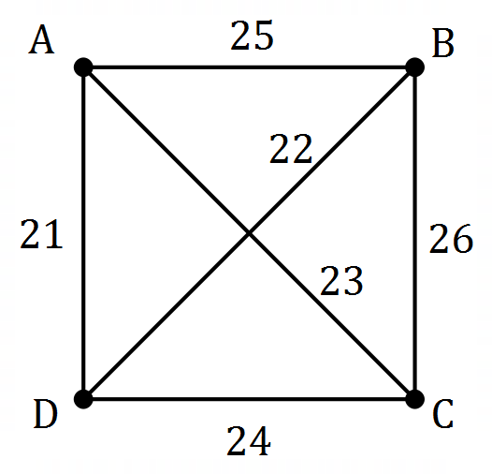
(example solution)
Specific behaviours
four labelled vertices
✓ six edges
✓ correct weights

(b) Explain why the graph in part (a) is a complete graph. (2 marks)
Solution
It is a simple graph in which every vertex is joined to every other vertex by an edge.
Specific behaviours
states graph is simple
✓ states all pairs of edges joined

(c) Determine the route the driver should take to minimise delivery time and calculate the time they will arrive back at the depot if they spend $7$ minutes at each school handing over the packages. (3 marks)
Solution
$$DABCD=96$$
$$DACBD=92$$
$$DBACD=94$$

Route for minimum time is $DACBD$ (or reverse)

Time taken is $92+3×7=113 \text{minutes}$.

Arrive back at $10:23 \text{am}$

Specific behaviours
✓ evidence of times for at least $2$ routes
lists optimum route
✓ correct arrival time

Question 16 (6 marks)
An electric kiln is switched on and after $n$ minutes, the temperature of the kiln $T_{n}$ is given by the recursive rule $T_{n+1}=1.35T_{n}$. The initial temperature of the kiln, $T_{0}$, is $25°C$.

(a) Calculate the temperature of the kiln after $1$ minute. (1 mark)
Solution
$$T_{1}=1.35×25=33.75°C$$

Specific behaviours
temperature that rounds to $34°C$

(b) Graph the temperature of the kiln for $n=0, 1, 2, 3, 4, 5$ and $6$ on the axes below. (3 marks)

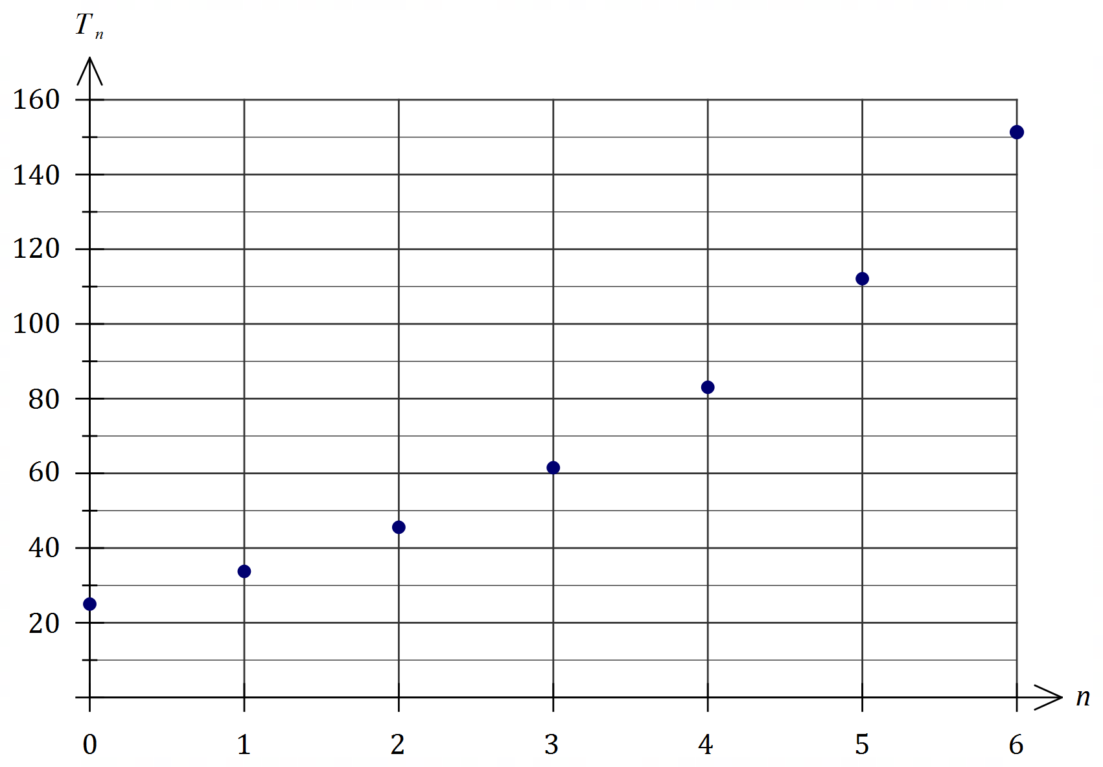
Solution
See graph
Specific behaviours
correct $T_{0}$ and $T_{6}$
✓ at least 2 other points plotted accurately
✓ all points plotted accurately
-1 if joined

(c) Name the type of growth displayed in the graph. (1 mark)
Solution
Exponential or Geometric
Specific behaviours
correct term

(d) During which minute does the temperature of the kiln first increase by more than $200°C$?
(1 mark)
Solution
During the $12$^{th} minute (from $679°C$ to $916°C$)

Specific behaviours
correct minute

Question 17 (8 marks)
A customer in a store is offered a reducible interest loan that attracts interest of $8.4\%$ compounded monthly to purchase a $\$2 545.39$ computer and accessories. The monthly loan repayment is $\$151$.

The customer set up the spreadsheet below to analyse the loan, rounding the displayed figures to the nearest cent.

Month | Balance at start of month ($) | Interest for month | Repayment | Balance at end of month ($)
$$1$$ | $$2 545.39$$ | $$17.82$$ | $$151.00$$ | $$2 412.21$$
$$2$$ | $$2 412.21$$ | $$16.89$$ | $$151.00$$ | $$2 278.09$$
$$3$$ | $$2 278.09$$ | $$15.95$$ | $$151.00$$ | $$2143.04$$

(a) Complete row $3$ of the spreadsheet. (3 marks)
Solution
See table
Specific behaviours
opening balance and repayment
✓ interest
✓ closing balance

(b) Determine a simplified recurrence relation for $B_{n}$, the loan balance at the start of month $n$.
(2 marks)
Solution
$$1+8.4÷12÷100=1.007$$

$$B_{n+1}={1.007B}_{n}-151, B_{1}=2545.39$$

Specific behaviours
interest multiplier
✓ recurrence relation and first term

(c) State the number of repayments required to pay off the loan. (1 mark)
Solution
$18$ repayments

Specific behaviours
correct number

(d) Determine the total amount of interest paid over the life of the loan. (2 marks)
Solution
Total payments: $18×151=2718$

$$I=2718-2545.39=\$172.61$$

Specific behaviours
total payments
✓ interest

Question 18 (9 marks)
An experiment involved measuring the voltage $v$ in a circuit after $t$ seconds. The equation of the least-squares line to model the linear relationship between $v$ and $t$ is given by $v=5.54-0.31t$ and $r_{vt}=-0.935$.

The residual plot for the linear model is shown below.

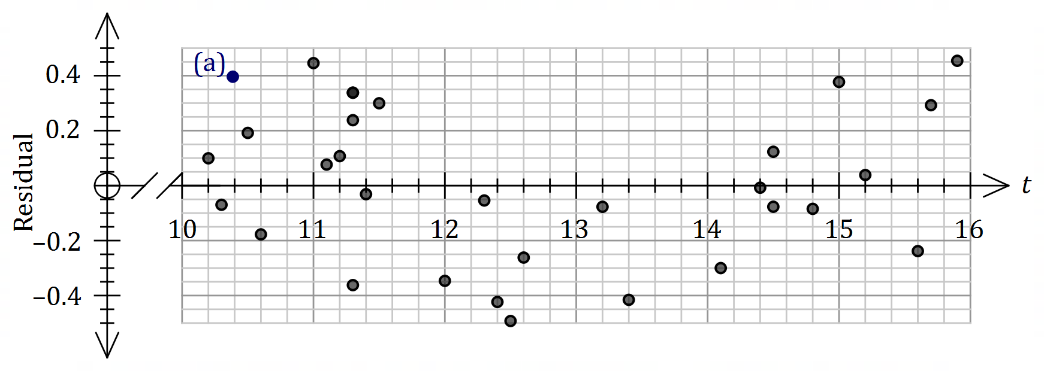

(a) After $10.4$ seconds, the measured voltage was $2.72$. Calculate the residual for this point and add it to the plot above. (3 marks)
Solution
$$v=5.54-0.31\left(10.4\right)=2.316$$
$$\text{Residual}=2.72-2.316=0.404$$
Specific behaviours
predicts voltage
✓ calculates residual
✓ plots residual

(b) Explain what information in this question

(i) supports the use of the linear model. (2 marks)
Solution
The correlation coefficient of $-0.935$ indicates a strong association between the variables.
Specific behaviours
states correlation
✓ states that correlation is strong

(ii) does not support the use of the linear model. (2 marks)
Solution
A pattern is evident in the residuals (tend to change from positive to negative to positive as time increases) which indicates that the linear model is not appropriate.
Specific behaviours
refers to residual plot
✓ states a pattern is evident

(c) The residual for the voltage measured after $12$ seconds is shown on the plot above. Determine what voltage was measured at this time. (2 marks)
Solution
$$5.54-0.31\left(12\right)=1.82$$
$$v-1.82=-0.35⇒v=1.47$$
Specific behaviours
residual from plot $[-0.34, -0.36]$
✓ measured voltage [$1.46, 1.48]$

Question 19 (7 marks)
An annuity compounds interest annually and its value after $n$ withdrawals can be modelled using the recurrence relation

$$T_{n+1}=1.054T_{n}-37 500, T_{0}=478 000.$$

(a) Use the relation to state

(i) the annual percentage interest rate. (1 mark)
Solution
$$5.4\%$$
Specific behaviours
correct value

(ii) the initial value of the annuity. (1 mark)
Solution
$$\$478 000$$
Specific behaviours
correct value

(b) Calculate the balance of the annuity, to the nearest dollar, after $4$ withdrawals. (1 mark)
Solution
$$T_{4}=\$427 323$$

Specific behaviours
correct value

(c) The annuity is closed after $15$ withdrawals. Calculate the total interest paid by the annuity up to this time. (2 marks)
Solution
$$T_{15}=218062.16$$

$$T_{15}-\left(T_{0}-15×37500\right)=\$302 562.16$$

Specific behaviours
indicates correct method
✓ correct amount

(d) From the outset, the annual withdrawal can be reduced so that the annuity becomes a perpetuity. Briefly explain what a perpetuity is and determine the withdrawal required.
(2 marks)
Solution
A perpetuity is an annuity in which the withdrawal equals the interest paid each time period and so the withdrawal can be made for ever.

Withdrawal will be $\$25 812$.

Specific behaviours
satisfactory explanation of perpetuity
✓ correct new withdrawal

Question 20 (10 marks)
The number of people ($n$, in thousands) studying in Australia with a student visa from $2015$ to $2017$ are shown in the graph and table below.

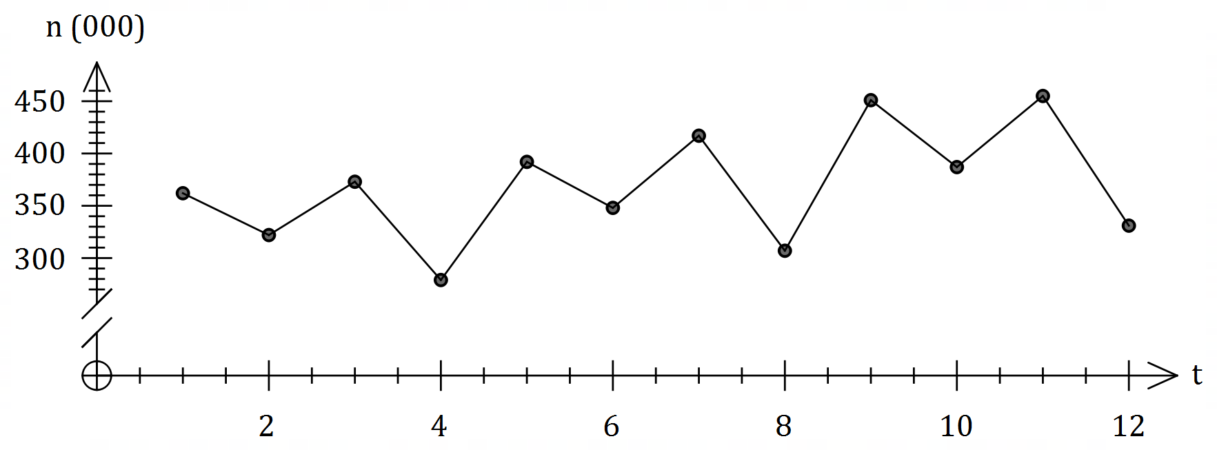

Year | Quarter | Time ($t$) | Number ($n$ $000$'s) | Quarterly mean | Percentage of quarterly mean
$$2015$$ | $$1$$ | $$1$$ | $$362$$ | $$A$$ | $$108.4$$
 | $$2$$ | $$2$$ | $$322$$ |  | $$96.4$$
 | $$3$$ | $$3$$ | $$373$$ |  | $$111.7$$
 | $$4$$ | $$4$$ | $$279$$ |  | $$83.5$$
$$2016$$ | $$1$$ | $$5$$ | $$392$$ | $$366$$ | $$B$$
 | $$2$$ | $$6$$ | $$348$$ |  | $$95.1$$
 | $$3$$ | $$7$$ | $$417$$ |  | $$113.9$$
 | $$4$$ | $$8$$ | $$307$$ |  | $$83.9$$
$$2017$$ | $$1$$ | $$9$$ | $$451$$ | $$406$$ | $$111.1$$
 | $$2$$ | $$10$$ | $$387$$ |  | $$95.3$$
 | $$3$$ | $$11$$ | $$455$$ |  | $$112.1$$
 | $$4$$ | $$12$$ | $$C$$ |  | $$81.5$$

(a) Determine the value of $A$, the value of $B$ and the value of $C$ in the table above. (3 marks)
Solution
$$A=\left(362+322+373+279\right)÷4=334$$

$$B=392÷366=1.071=107.1\%$$

$$C=4×406-451-387-455=331$$

Specific behaviours
value of $A$
✓ value of $B$
✓ value of $C$

(b) Complete the missing values in the seasonal index table below. (2 marks)

Quarter | $$1$$ | $$2$$ | $$3$$ | $$4$$
Seasonal Index | $$1.089$$ | $$0.956$$ | $$1.126$$ | $$0.829$$
Solution
$$Q2:\left(96.4+951.+95.3\right)÷3=0.956$$

$$Q3:4-\left(1.089+0.956+0.829\right)=1.126$$

Specific behaviours
one correct value
✓ both correct values

(c) Calculate the deseasonalised number of people studying in Australia with a student visa in the fourth quarter of $2016$. (2 marks)
Solution
$$307÷0.829=370.3$$

Number of people is $370 300$

Specific behaviours
indicates correct calculation
✓ correct figure, allowing for thousands

Let $N$ represent all the deseasonalised values of $n$. The equation of the least-squares line for $N$ against $t$ is given by $N=7.96t+316.9$.

(d) Determine an estimate for the number of people studying in Australia with a student visa in the fourth quarter of $2018$ if the existing trend and seasonality continues. (3 marks)
Solution
$$t=16$$

$$N=7.96\left(16\right)+316.9=444.26$$

$$\text{Estimate}=444.26×0.829≈368 \text{thousand people}$$

Specific behaviours
uses $t=16$
✓ correct value of $N$
✓ correct estimate, allowing for thousands

Question 21 (10 marks)
A reverse mortgage is a loan that allows a person to borrow money using their home as security. Interest is charged like any other loan, but no repayments are made - the interest compounds over time and is added to the loan balance.

At the start of January $2019$, a borrower takes out a reverse mortgage for $\$155 000$ at an interest rate of $6.54\%$ per annum, compounded monthly.

(a) State a simplified recurrence relation for $T_{n}$, the loan balance after $n$ months. (2 marks)
Solution
$$1+6.54÷12÷100=1.00545$$

$$T_{n+1}={1.00545T}_{n}, T_{0}=155000$$

Specific behaviours
interest multiplier
✓ recurrence relation

(b) Determine the loan balance at the start of January $2022$. (2 marks)
Solution
Interest periods $=3×12=36$

$$T_{36}=\$188 498.94$$

Specific behaviours
✓ number of periods
correct balance

(c) Determine the effective interest rate of the reverse mortgage, correct to $4$ decimal places.
(1 mark)
Solution
$$E=6.7396\%$$

Specific behaviours
correct rate

The borrower's home was valued at $\$420 000$ at the time they took out the reverse mortgage and was expected to appreciate at a rate of $2.5\%$ per annum.

(d) Use a recurrence relation to determine the value of the home at the start of January $2022$.
(2 marks)
Solution
$$V_{n+1}={1.025V}_{n}, V_{0}=420000$$

$$V_{3}=452 294$$

Specific behaviours
use of recurrence relation
✓ value that rounds to figure shown

(e) At the start of which calendar year will the loan balance first exceed the value of the home? Justify your answer. (3 marks)
Solution
After $n$ years, loan balance: $B_{n+1}={1.067396B}_{n}, B_{0}=155000$

$$B_{24}=741565, V_{24}=759665$$

$$B_{25}=791544, V_{25}=778657$$

$$2019+25=2044$$

Loan first exceeds value at the start of year 2044.

Specific behaviours
indicates method
✓ shows will take 25 years
✓ correct year

Supplementary page

Question number: _________

Supplementary page

Question number: _________

© 2019 WA Exam Papers. Kennedy Baptist College has a non-exclusive licence to copy and communicate this document for non-commercial, educational use within the school. No other copying, communication or use is permitted without the express written permission of WA Exam Papers. SN245-146-4.

